Dentally API: Sample Requests, Responses and Schema
Oct 14, 2026 · @Tamil

Conventions
This document covers all 86 REST endpoints in the Dentally API with a sample request and response for each. Single resources come back wrapped in their singular name, lists in the plural name plus a meta object, and request bodies must be wrapped in the singular name.
Environment | Base URL
Production | https://api.dentally.co
Sandbox | https://api.sandbox.dentally.co
APAC practices | https://api.apac.dentally.com
Canadian practices | https://api.ca.dentally.com
Every request needs these headers. The samples below leave them out to stay short.
Authorization: Bearer ACCESS_TOKEN
User-Agent: Awesome-Dental-App v1
Content-Type: application/json (writes only)
A missing User-Agent returns 403 Forbidden. Paths are shown with the explicit /v1 prefix; omitting it returns the latest version.
- Pagination: page and per_page (default 25, max 100; availability max 20). Avoid going past page 100.
- Sorting: sort_by=<attribute>&sort_direction=asc|desc on most lists.
- Date filters: use them on large lists such as appointments, and keep before/after windows under 3 months.
- Metadata: patients and appointments accept a metadata hash of up to 3 keys (key max 40 chars, value max 500).
- Deletes return 204 No Content. Deleting a patient only sets active to false.
- Timestamps are ISO 8601 with a timezone offset.
Rate limits: 3,600 requests per hour per user, and 200 per hour for appointment availability. Going over returns 403.
{ "error": { "type": "invalid_access_error", "message": "Rate limit exceeded" } }
Validation error (422):
{
"error": {
"type": "invalid_request_error",
"message": "The patient could not be saved",
"params": { "first_name": ["seems to be missing"] }
}
}
Access error (403):
{
"error": {
"type": "invalid_access_error",
"message": "API access is not enabled for this user",
"documentation_url": "https://developer.dentally.co"
}
}
Status | Meaning
200 | OK
204 | No content (deletes)
400 | Bad request, often a missing parameter
401 | Unauthorized, invalid token
403 | Forbidden, no access or rate limited
404 | Not found
410 | Gone
422 | Unprocessable entity, reason in error.params
500 / 503 | Server error / maintenance
OAuth scopes: appointment (read, create, update, delete), financials (read, create, delete), patient (read, create, update, delete = archive), practice (read, update), treatments (treatments, treatment plans and items), user (read, update). Request only what you need.

Patients and related resources
Patients are the hub of the model. Their account, appointments, treatment plans, recalls, referrals, stats and PRSI eligibilities all hang off patient_id.

Patients

Create a patient
Required: title, first_name, last_name, date_of_birth, gender, ethnicity, address_line_1, postcode, payment_plan_id. If you send emergency_contact_name or emergency_contact_relationship, you must also send emergency_contact_phone.
POST /v1/patients
{
"patient": {
"title": "Mr", "first_name": "John", "last_name": "Smith",
"date_of_birth": "1980-01-01", "gender": true, "ethnicity": "99",
"address_line_1": "21 Oak Avenue", "postcode": "W1A 1AA", "payment_plan_id": 1
}
}

{
"patient": {
"id": 3, "account_id": 3, "active": true,
"address_line_1": "21 Oak Avenue", "address_line_2": null, "county": null,
"created_at": "2014-09-11T14:48:01.563+01:00", "date_of_birth": "1980-01-01",
"dentist_id": null, "dentist_recall_date": null, "dentist_recall_interval": 0,
"email_address": null, "ethnicity": "99", "first_name": "John", "gender": true,
"home_phone": null, "home_phone_country": "GB",
"hygienist_id": null, "hygienist_recall_date": null, "hygienist_recall_interval": 0,
"image_url": "https://www.gravatar.com/avatar/fb830e28cd031264e371ab85563b37b0.jpg?&r=pg&d=identicon&s=190",
"last_name": "Smith", "legacy_id": null, "medical_alert": false, "medical_alert_text": null,
"metadata": {}, "middle_name": null, "mobile_phone": null, "mobile_phone_country": "GB",
"nhs_number": null, "ni_number": null, "occupation": null, "payment_plan_id": 1,
"postcode": "W1A 1AA", "preferred_name": null, "preferred_phone_number": null,
"recall_method": "Letter", "site_id": "e1d854af-15db-4482-8e29-39e74a6c7f75",
"title": "Mr", "town": null, "updated_at": "2014-09-11T14:48:01.563+01:00",
"use_email": true, "use_sms": true, "work_phone": null, "work_phone_country": "GB",
"emergency_contact_name": null, "emergency_contact_relationship": null,
"emergency_contact_phone": null, "emergency_contact_phone_country": "GB",
"emergency_contact_phone_normalized": null
}
}

Get a patient
GET /v1/patients/1

{
"patient": {
"id": 1, "account_id": 1, "active": true,
"acquisition_source_id": "abdcdeb5-ebe4-4629-a375-15e1506d3961",
"address_line_1": "135 New Crescent", "address_line_2": "Trlr 882", "county": "Breconshire",
"consent_to_share_accounts": false, "created_at": "2013-11-04T03:07:33.954+00:00",
"custom_fields": [
{ "value": true, "field_id": "2c19fdf0-987c-4e5a-aa71-06ad8a58ee22", "position": 0 },
{ "value": false, "field_id": "38b96e14-e31d-477b-a1c0-1538ff4cf360", "position": 1 }
],
"custom_field_1": "92837484", "custom_field_2": null,
"date_of_birth": "1975-10-23", "dentist_id": null, "dentist_recall_date": null,
"dentist_recall_interval": 12, "email_address": "patient@dentalpractice.com",
"ethnicity": "07", "family_id": "abdcdeb5-ebe4-4629-a375-15e1506d3961",
"first_name": "Alesha", "gender": false, "home_phone": "013332511673", "home_phone_country": "GB",
"hygienist_id": null, "hygienist_recall_date": null, "hygienist_recall_interval": 12,
"image_url": "https://www.gravatar.com/avatar/7a37035f9ccdd683c05435e07c60ff90.jpg?&r=pg&d=identicon&s=190",
"last_name": "Chaney", "legacy_id": null, "marketing": true,
"medical_alert": false, "medical_alert_text": null, "metadata": {}, "middle_name": "Kiara",
"mobile_phone": "07306743470", "mobile_phone_country": "GB",
"nhs_number": "7474158055", "ni_number": null, "occupation": "Doctor", "payment_plan_id": 2,
"postcode": "DG11 6JM", "pps_number": "4567893W", "preferred_name": null,
"preferred_phone_number": 3, "recall_method": "Letter",
"site_id": "e1d854af-15db-4482-8e29-39e74a6c7f75", "title": "Ms", "town": "Giffnock",
"updated_at": "2013-11-04T03:07:33.954+00:00", "use_email": false, "use_sms": true,
"work_phone": "020303132213", "work_phone_country": "GB",
"emergency_contact_name": "Jim", "emergency_contact_relationship": "Friend",
"emergency_contact_phone": "07306743470", "emergency_contact_phone_country": "GB",
"emergency_contact_phone_normalized": "+447306743470"
}
}

Edit a patient
Any create field can be sent; none are required. PUT and PATCH are both accepted.
PATCH /v1/patients/3
{ "patient": { "first_name": "Frank", "occupation": "Doctor" } }

{
"patient": {
"id": 3, "account_id": 3, "active": true, "first_name": "Frank", "last_name": "Smith",
"date_of_birth": "1980-01-01", "gender": true, "ethnicity": "99",
"address_line_1": "21 Oak Avenue", "postcode": "W1A 1AA", "occupation": "Doctor",
"payment_plan_id": 1, "recall_method": "Letter", "metadata": {},
"site_id": "e1d854af-15db-4482-8e29-39e74a6c7f75", "title": "Mr",
"created_at": "2014-09-11T14:48:01.563+01:00", "updated_at": "2014-09-12T09:10:11.000+01:00"
}
}
The response is trimmed here. It has the same shape as Get a patient.

Delete (archive) a patient
Sets active to false. Set it back to true with an edit to undo.
DELETE /v1/patients/1
Response: 204 No Content

List patients
Filters: query (names, postcode, date of birth, email or phone; include * to return inactive patients), updated_after, created_after, payment_plan_id, site_id.
GET /v1/patients?query=al&site_id=e1d854af-15db-4482-8e29-39e74a6c7f75&per_page=25

{
"patients": [
{
"id": 1, "account_id": 1, "active": true, "first_name": "Alesha", "last_name": "Chaney",
"title": "Ms", "date_of_birth": "1975-10-23", "email_address": "patient@dentalpractice.com",
"mobile_phone": "07306743470", "postcode": "DG11 6JM", "payment_plan_id": 2,
"site_id": "e1d854af-15db-4482-8e29-39e74a6c7f75", "metadata": {}
}
],
"meta": { "total": 3, "page": 1 }
}
Items are trimmed here. Each one has the full patient shape.

Patient referrals
referrable_type is one of Referrals::PrivateIngroupReferral, Referrals::PrivateInhouseReferral, Referrals::PrivateExternalReferral, Referrals::NhsExternalReferral. status is one of draft, submitted, accepted, booked, completed, rejected.

Get a patient referral
GET /v1/patient_referrals/122

{
"patient_referral": {
"id": 122, "created_at": "2026-03-24T09:55:56.473+00:00", "patient_id": 941,
"patient_referral_reasons": [
{ "referral_reason_id": "6c7db82d-d013-455d-8d8c-d76556c4ada7", "name": "Capacity constraints" },
{ "referral_reason_id": "4857f623-ae5e-48fe-90bb-642cd05713a1", "name": "Funding requirements" }
],
"reference": "REF-000122",
"referrable_type": "Referrals::PrivateIngroupReferral",
"referrable_attributes": {
"additional_information": null, "consented_by_patient": true,
"referred_practitioner_id": null, "referred_site_id": "0406e162-58c5-4384-bfe0-e842ab4fa4cf"
},
"services_appointment_id": "4590d1cb-0e1f-4604-8536-c53fa38037e6",
"site_id": "e1d854af-15db-4482-8e29-39e74a6c7f75", "status": "submitted",
"updated_at": "2026-03-24T09:56:44.325+00:00", "user_id": 31813
}
}

List patient referrals
Filters: site_id, referrable_type, created_after, created_before.
GET /v1/patient_referrals?referrable_type=Referrals::PrivateIngroupReferral&created_after=2026-03-01

{
"patient_referrals": [
{
"id": 122, "created_at": "2026-03-24T09:55:56.473+00:00", "patient_id": 941,
"reference": "REF-000122", "referrable_type": "Referrals::PrivateIngroupReferral",
"referrable_attributes": { "consented_by_patient": true, "referred_practitioner_id": 1, "referred_site_id": "0406e162-58c5-4384-bfe0-e842ab4fa4cf" },
"site_id": "e1d854af-15db-4482-8e29-39e74a6c7f75", "status": "submitted", "user_id": 31813
}
],
"meta": { "total": 1, "current_page": 1, "total_pages": 1 }
}

Patient stats

Get a patient's stats
GET /v1/patients/52/stats

{
"patient_stat": {
"patient_id": 52,
"first_appointment_date": "2016-01-11T16:00:00.000+00:00", "first_exam_date": "2016-01-11T16:00:00.000+00:00",
"last_appointment_date": "2016-06-09T14:00:00.000+01:00", "last_cancelled_appointment_date": null,
"last_exam_date": "2016-01-11T16:00:00.000+00:00", "last_fta_appointment_date": "2018-09-18T10:00:00.000+01:00",
"last_scale_and_polish_date": null, "next_appointment_date": null,
"next_exam_date": null, "next_scale_and_polish_date": null,
"nhs_exemption_code": null, "total_invoiced": "0.0", "total_paid": "0.0",
"created_at": "2015-10-20T23:21:46.690+01:00", "updated_at": "2018-09-19T01:00:36.638+01:00"
}
}

List patient stats
Filters: created_at_after, created_at_before, updated_at_after, updated_at_before.
GET /v1/patient_stats?updated_at_after=2018-09-01

{
"patient_stats": [
{
"patient_id": 52, "last_appointment_date": "2016-06-09T14:00:00.000+01:00",
"last_exam_date": "2016-01-11T16:00:00.000+00:00", "next_appointment_date": null,
"total_invoiced": "0.0", "total_paid": "0.0", "nhs_exemption_code": null,
"created_at": "2015-10-20T23:21:46.690+01:00", "updated_at": "2018-09-19T01:00:36.638+01:00"
}
],
"meta": { "total": 3, "page": 1 }
}

Acquisition sources

List acquisition sources
Ordered by name.
GET /v1/acquisition_sources

{
"acquisition_sources": [
{ "id": "abdcdeb5-ebe4-4629-a375-15e1506d3961", "active": true, "name": "Flyer", "notes": "Posted Aug 2023" }
],
"meta": { "total": 3, "page": 1 }
}

Custom fields
A patient's or treatment plan item's custom_fields[].field_id points at one of these records.

List custom fields
Filters: active, updated_after, updated_before.
GET /v1/custom_fields?active=true&updated_after=2021-08-21&updated_before=2021-08-25

{
"custom_fields": [
{
"id": "5427b8d4-eacd-4e6a-8a4a-f2a37979425c", "active": true,
"created_at": "2020-05-19T08:32:36.008+01:00", "updated_at": "2020-05-19T08:32:36.008+01:00",
"customizable_id": "a243bf5f-72a8-4e52-9fd7-62b729e8544c", "customizable_type": "Treatment",
"default_value": null, "description": null, "name": "Registration Status",
"options": [
{ "name": "Registered at the practice", "position": 0 },
{ "name": "New patient", "position": 1 },
{ "name": "Emergency referral", "position": 2 }
],
"position": 0, "type": "enum", "width": 5
}
],
"meta": { "total": 1, "current_page": 1, "total_pages": 1 }
}

Get a custom field
GET /v1/custom_fields/5427b8d4-eacd-4e6a-8a4a-f2a37979425c

{
"custom_field": {
"id": "5427b8d4-eacd-4e6a-8a4a-f2a37979425c", "active": true,
"created_at": "2020-05-19T08:32:36.008+01:00", "updated_at": "2020-05-19T08:32:36.008+01:00",
"customizable_id": "a243bf5f-72a8-4e52-9fd7-62b729e8544c", "customizable_type": "Treatment",
"default_value": null, "description": null, "name": "Registration Status",
"options": [ { "name": "Registered at the practice", "position": 0 }, { "name": "New patient", "position": 1 } ],
"position": 0, "type": "enum"
}
}

Recalls

List recalls
Filters: created_after, created_before, updated_after, prebooked (default false).
GET /v1/recalls?created_after=2021-09-01&prebooked=false

{
"recalls": [
{
"id": "4cefeeed-0723-4095-8b0d-ff16943d1af8", "patient_id": 2,
"appointment_id": "de63f346-5426-4321-45t4-7c0aar13e443", "due_date": "2021-09-30",
"first_reminder_id": "fe53d337-4693-4478-86b9-8b0aaa13e483",
"first_reminder_sent_at": "2021-09-30T13:24:57.107+01:00", "first_reminder_type": "Email",
"second_reminder_id": "45b14ca1-4b59-475c-80af-7f711ba1fd8e",
"second_reminder_sent_at": "2021-09-30T13:24:57.107+01:00", "second_reminder_type": "Letter",
"last_reminded_at": "2021-09-30T13:24:57.107+01:00", "latest_reminder_type": "Email",
"prebooked": false,
"reminders": [
{ "type": "Email", "id": "fe53d337-4693-4478-86b9-8b0aaa13e483", "date": "2021-09-30T13:24:57.107+01:00", "template_name": "Default recall template" },
{ "type": "Letter", "id": "45b14ca1-4b59-475c-80af-7f711ba1fd8e", "date": "2021-09-30T13:24:57.107+01:00", "template_name": "Default recall template" }
],
"recall_method": "SMS", "recall_type": "Dentist", "status": "Completed",
"times_contacted": 2, "run_date": null, "workflow_stage_id": null, "workflow_status": "unprocessed"
}
],
"meta": { "total": 1, "current_page": 1, "total_pages": 1 }
}

Waiting lists

Get a waiting list
GET /v1/waiting_lists/751c9241-62de-40aa-8f8f-6a0326032e44

{
"waiting_list": {
"id": "751c9241-62de-40aa-8f8f-6a0326032e44", "active": true, "appointment_reasons": [],
"created_at": "2019-09-05T16:31:38.910+01:00", "updated_at": "2023-02-21T14:36:37.041+00:00",
"default_appointment_duration": 5, "default_appointment_reason": "Exam",
"default_notes": null, "default_status": "waiting",
"default_treatment_duration": 5, "default_treatment_reason": "Exam",
"name": "Grahams List", "site_id": "0406e162-58c5-4384-bfe0-e842ab4fa4cf",
"target_appointment_days": null, "target_treatment_days": null
}
}
The source docs show this response as an array. See the notes at the end.

List waiting lists
Filter: site_id.
GET /v1/waiting_lists?site_id=0406e162-58c5-4384-bfe0-e842ab4fa4cf

{
"waiting_lists": [
{
"id": "ddcac4b7-9fd6-40ec-b969-38795066502b", "active": true,
"appointment_reasons": ["Exam", "Scale and Polish"],
"default_appointment_duration": 5, "default_appointment_reason": "Exam",
"default_notes": null, "default_status": "waiting",
"default_treatment_duration": 5, "default_treatment_reason": "Exam",
"name": "Stuff", "target_appointment_days": null, "target_treatment_days": null,
"created_at": "2019-09-05T16:24:41.382+01:00", "updated_at": "2019-09-05T16:24:41.382+01:00",
"site_id": "0406e162-58c5-4384-bfe0-e842ab4fa4cf"
}
],
"meta": { "total": 2, "current_page": 1, "total_pages": 1 }
}

Waiting list entries

Get waiting list entries
waiting_list_id is required. The docs list the path as /v1/waiting_list_entries/{WAITING_LIST_ID} but the example call uses a query parameter, which is what this sample follows.
GET /v1/waiting_list_entries?waiting_list_id=751c9241-62de-40aa-8f8f-6a0326032e44

{
"waiting_list_entries": [
{
"id": "b758069a-aec5-45e8-8874-50196e72936d", "waiting_list_id": "751c9241-62de-40aa-8f8f-6a0326032e44",
"patient_id": "276e47ce-3976-4317-b474-a349a5fe92c8", "patient_sid": 896, "patient_name": "laura adam",
"practitioner_id": "0c6ce55b-4751-4347-b287-23cc87688143", "practitioner_sid": 4,
"appointment_id": "3429c60d-9d0b-4f5b-add3-95f9edd3dc80", "appointment_sid": 46750712,
"appointment_actual_on": null, "appointment_target_on": null, "appointment_treatment_id": null,
"specialist_id": null, "specialist_sid": null, "referral_on": null, "site_id": null,
"status": "booked", "priority": 2, "archived": false, "notes": "i am waiting",
"listed_on": "2023-03-22", "days_waiting_appointment": 8, "days_waiting_treatment": 0,
"treatment_actual_on": null, "treatment_target_on": null,
"history": [
{
"changes": { "status": ["waiting", "booked"], "appointment_id": [null, "3429c60d-9d0b-4f5b-add3-95f9edd3dc80"] },
"history_at": "2023-03-22T15:31:53.344+00:00", "history_by": 1, "changed_count": 3
}
],
"last_edited_by_id": 1, "user_id": 1,
"created_at": "2023-03-22T15:30:47.571+00:00", "updated_at": "2023-03-22T15:31:53.352+00:00"
}
],
"meta": { "total": 2, "current_page": 1, "total_pages": 1 }
}

PRSI eligibilities
Irish PRSI dental benefit checks per patient. exam_eligible_status and hygienist_eligible_status are one of Eligible, Expired, Used, None.

List PRSI eligibilities
Filters: eligible_check_date_after/_before, expiry_date_after/_before, hygienist_eligible_status, exam_eligible_status, patient_consented, site_id, patient_id.
GET /v1/prsi_eligibilities?eligible_check_date_after=2024-02-29

{
"prsi_eligibilities": [
{
"id": "80d0d7be-b2da-4cc8-833a-fefea0d17456",
"eligible_check_date": "2024-04-19T00:00:00.000+01:00", "expiry_date": "2025-04-19T00:00:00.000+01:00",
"exam_eligible_status": "Eligible", "hygienist_eligible_status": "Eligible", "patient_consented": true,
"patient_id": "0f4a6af2-2a52-4be5-a27a-a49f52b7f381", "site_id": "0406e162-58c5-4384-bfe0-e842ab4fa4cf", "user_id": 1,
"created_at": "2024-05-02T08:53:43.799+01:00", "updated_at": "2024-05-02T08:53:43.799+01:00"
}
],
"meta": { "total": 2, "current_page": 1, "total_pages": 1 }
}

Get a PRSI eligibility
GET /v1/prsi_eligibilities/d7c1781a-2d7d-4d50-8de8-a2b5e5306a91

{
"prsi_eligibility": {
"id": "d7c1781a-2d7d-4d50-8de8-a2b5e5306a91",
"eligible_check_date": "2024-04-19T00:00:00.000+01:00", "expiry_date": "2025-04-19T00:00:00.000+01:00",
"exam_eligible_status": "Eligible", "hygienist_eligible_status": "Eligible", "patient_consented": true,
"patient_id": "0f4a6af2-2a52-4be5-a27a-a49f52b7f381", "site_id": "0406e162-58c5-4384-bfe0-e842ab4fa4cf", "user_id": 1,
"created_at": "2024-05-02T08:53:55.585+01:00", "updated_at": "2024-05-02T08:53:55.585+01:00"
}
}

Create a PRSI eligibility
Required: patient_id, patient_consented, eligible_check_date, expiry_date. Statuses default to None.
POST /v1/prsi_eligibilities
{
"prsi_eligibility": {
"patient_id": "0f4a6af2-2a52-4be5-a27a-a49f52b7f381", "patient_consented": true,
"eligible_check_date": "19/04/2024", "expiry_date": "19/04/2025"
}
}

{
"prsi_eligibility": {
"id": "02d0f5f6-30e2-46aa-a257-036c3e744d9d",
"eligible_check_date": "2024-04-19T00:00:00.000+01:00", "expiry_date": "2025-04-19T00:00:00.000+01:00",
"exam_eligible_status": "None", "hygienist_eligible_status": "None", "patient_consented": true,
"patient_id": "0f4a6af2-2a52-4be5-a27a-a49f52b7f381", "site_id": "0406e162-58c5-4384-bfe0-e842ab4fa4cf", "user_id": 1,
"created_at": "2024-05-02T10:16:42.382+01:00", "updated_at": "2024-05-02T10:16:42.382+01:00"
}
}

Edit a PRSI eligibility
PATCH /v1/prsi_eligibilities/d7c1781a-2d7d-4d50-8de8-a2b5e5306a91
{ "prsi_eligibility": { "exam_eligible_status": "Expired", "hygienist_eligible_status": "Eligible" } }

{
"prsi_eligibility": {
"id": "d7c1781a-2d7d-4d50-8de8-a2b5e5306a91",
"eligible_check_date": "2024-04-19T00:00:00.000+01:00", "expiry_date": "2025-04-19T00:00:00.000+01:00",
"exam_eligible_status": "Expired", "hygienist_eligible_status": "Eligible", "patient_consented": true,
"patient_id": "0f4a6af2-2a52-4be5-a27a-a49f52b7f381", "site_id": "0406e162-58c5-4384-bfe0-e842ab4fa4cf", "user_id": 1,
"created_at": "2024-05-02T08:53:55.585+01:00", "updated_at": "2024-05-02T10:58:22.511+01:00"
}
}

Delete a PRSI eligibility
DELETE /v1/prsi_eligibilities/90205d1d-9e07-43ee-9a95-245995cb1f42
Response: 204 No Content

Appointments and scheduling
Appointments link a patient, a practitioner and optionally a room. state is one of Pending, Confirmed, Arrived, In surgery, Completed, Cancelled, Did not attend, and changing it stamps the matching *_at field. reason is one of Exam, Scale & Polish, Exam + Scale & Polish, Continuing Treatment, Emergency, Review, Other.

Appointments

Create an appointment
Required: start_time, finish_time, practitioner_id, reason. Optional: patient_id, state (default Pending), notes, metadata, force_changes (allows double booking).
POST /v1/appointments
{
"appointment": {
"start_time": "2026-10-20T13:00:00.000Z", "finish_time": "2026-10-20T13:10:00.000Z",
"patient_id": 1, "practitioner_id": 1, "reason": "Exam"
}
}

{
"appointment": {
"id": 14493, "uuid": "f7b1b1b0-0b1b-4b1b-8b1b-2a2b5b6b1e1c",
"appointment_cancellation_reason_id": null, "booked_via_api": true,
"pending_at": "2026-10-14T13:42:14.424+00:00", "confirmed_at": null, "arrived_at": null,
"in_surgery_at": null, "completed_at": null, "cancelled_at": null, "did_not_attend_at": null,
"duration": 10, "start_time": "2026-10-20T13:00:00.000+00:00", "finish_time": "2026-10-20T13:10:00.000+00:00",
"metadata": {}, "notes": null,
"patient_id": 1, "patient_name": "Liza Stafford",
"patient_image_url": "https://www.gravatar.com/avatar/d80c726c2a3a8f426acaa06e16b05b09.jpg?&r=pg&d=identicon&s=190",
"payment_plan_id": 1, "practitioner_id": 1, "reason": "Exam",
"room_id": null, "state": "Pending", "treatment_description": null, "user_id": 1
}
}

Get an appointment
GET /v1/appointments/14493

{
"appointment": {
"id": 14493, "uuid": "f7b1b1b0-0b1b-4b1b-8b1b-2a2b5b6b1e1c",
"appointment_cancellation_reason_id": null, "booked_via_api": true,
"pending_at": "2026-10-14T13:42:14.424+00:00", "confirmed_at": null, "arrived_at": null,
"in_surgery_at": null, "completed_at": null, "cancelled_at": null, "did_not_attend_at": null,
"duration": 10, "start_time": "2026-10-20T13:00:00.000+00:00", "finish_time": "2026-10-20T13:10:00.000+00:00",
"metadata": {}, "notes": null,
"patient_id": 1, "patient_name": "Liza Stafford",
"patient_image_url": "https://www.gravatar.com/avatar/d80c726c2a3a8f426acaa06e16b05b09.jpg?&r=pg&d=identicon&s=190",
"payment_plan_id": 1, "practitioner_id": 1, "reason": "Exam",
"room_id": "04b2db45-455a-42f7-b9ce-99fa6b0c741b", "state": "Pending",
"treatment_description": null, "user_id": 1
}
}

Edit an appointment
Updating state sets the matching timestamp automatically. PUT and PATCH are both accepted.
PATCH /v1/appointments/14493
{ "appointment": { "finish_time": "2026-10-20T13:15:00.000Z", "state": "Confirmed" } }

{
"appointment": {
"id": 14493, "uuid": "f7b1b1b0-0b1b-4b1b-8b1b-2a2b5b6b1e1c",
"appointment_cancellation_reason_id": null, "booked_via_api": true,
"pending_at": "2026-10-14T13:42:14.424+00:00", "confirmed_at": "2026-10-14T14:05:00.000+00:00",
"arrived_at": null, "in_surgery_at": null, "completed_at": null, "cancelled_at": null, "did_not_attend_at": null,
"duration": 15, "start_time": "2026-10-20T13:00:00.000+00:00", "finish_time": "2026-10-20T13:15:00.000+00:00",
"metadata": {}, "notes": null, "patient_id": 1, "patient_name": "Liza Stafford",
"payment_plan_id": 1, "practitioner_id": 1, "reason": "Exam",
"room_id": "04b2db45-455a-42f7-b9ce-99fa6b0c741b", "state": "Confirmed",
"treatment_description": null, "user_id": 1
}
}
The patient_image_url field is left out here and in the list below to save space.

Delete an appointment
Only use this to remove an appointment entirely. To cancel one, set state to Cancelled instead.
DELETE /v1/appointments/14493
Response: 204 No Content

List appointments
Filters (combinable): on, before, after, updated_after, practitioner_id, patient_id, room_id, site_id, state (case sensitive), cancelled (true includes cancelled and did-not-attend). Ordered by start time.
GET /v1/appointments?on=2026-10-20&practitioner_id=1&state=Pending

{
"appointments": [
{
"id": 14493, "appointment_cancellation_reason_id": null,
"pending_at": "2026-10-14T13:42:14.424+00:00", "confirmed_at": null, "arrived_at": null,
"in_surgery_at": null, "completed_at": null, "cancelled_at": null, "did_not_attend_at": null,
"duration": 15, "start_time": "2026-10-20T13:00:00.000+00:00", "finish_time": "2026-10-20T13:15:00.000+00:00",
"metadata": {}, "notes": null, "patient_id": 1, "patient_name": "Liza Stafford",
"payment_plan_id": 1, "practitioner_id": 1, "reason": "Exam",
"room_id": "04b2db45-455a-42f7-b9ce-99fa6b0c741b", "state": "Pending",
"treatment_description": null, "user_id": 1,
"created_at": "2026-10-14T13:42:14.424+00:00", "updated_at": "2026-10-14T13:42:14.424+00:00"
}
],
"meta": { "total": 3, "page": 1 }
}

Appointment availability
Required: start_time and finish_time (both in the future), practitioner_ids[]. Optional: duration in minutes, page, per_page (max 20). Limited to 200 requests per hour.
GET /v1/appointments/availability?practitioner_ids[]=1&duration=5&start_time=2026-10-20T12:00:11+00:00&finish_time=2026-11-19T12:00:11+00:00

{
"availability": [
{ "start_time": "2026-10-20T12:00:00.000+00:00", "finish_time": "2026-10-20T14:20:00.000+00:00", "available_duration": 140 },
{ "start_time": "2026-10-20T14:40:00.000+00:00", "finish_time": "2026-10-20T17:00:00.000+00:00", "available_duration": 140 }
],
"meta": { "page": 1 }
}

List appointment reasons
Filter: deleted.
GET /v1/appointment_reasons?deleted=false

{
"appointment_reasons": [
{ "id": "7a0a4a71-ecd0-4b0b-81d5-e1739aee88ba", "colour": "#ad00fc", "deleted": false, "exam": false, "hygiene": false, "position": 50, "reason": "NOT WORKING" },
{ "id": "430c6234-4f3d-424d-b1ea-a4d1bc728d36", "colour": "#25B0E6", "deleted": false, "exam": false, "hygiene": false, "position": 49, "reason": "LUNCH" }
],
"meta": { "total": 50, "page": 1 }
}

Appointment cancellation reasons

List appointment cancellation reasons
Filters: created_after, created_before, updated_after, updated_before. Ordered by reason.
GET /v1/appointment_cancellation_reasons?sort_by=created_at&sort_direction=asc

{
"appointment_cancellation_reasons": [
{
"id": "fcafb582-0434-4eb8-b990-01f5fa12904d", "archived": false,
"reason": "Patient - Cancelled", "reason_type": "cancelled",
"created_at": "2020-03-23T15:58:49.331+00:00", "updated_at": "2020-03-23T15:58:49.331+00:00"
}
],
"meta": { "total": 14, "current_page": 1, "total_pages": 1 }
}

Rooms

Get a room
GET /v1/rooms/04b2db45-455a-42f7-b9ce-99fa6b0c741b

{
"room": {
"id": "04b2db45-455a-42f7-b9ce-99fa6b0c741b", "calendar_position": null, "colour": "#A3F137",
"name": "Surgery 3", "import_id": null, "practice_id": 1,
"site_id": "e1d854af-15db-4482-8e29-39e74a6c7f75",
"created_at": "2018-01-02T15:27:15.461+00:00", "updated_at": "2018-01-02T15:27:15.461+00:00"
}
}

List rooms
Filter: site_id.
GET /v1/rooms?site_id=e1d854af-15db-4482-8e29-39e74a6c7f75

{
"rooms": [
{
"id": "984deaaf-9218-48fe-9034-20d0fe44f946", "calendar_position": null, "colour": "#a660a6",
"name": "Surgery 1", "import_id": null, "practice_id": 1,
"site_id": "e1d854af-15db-4482-8e29-39e74a6c7f75",
"created_at": "2017-01-26T14:49:47.426+00:00", "updated_at": "2017-01-26T14:49:47.426+00:00"
}
],
"meta": { "total": 4, "current_page": 1, "total_pages": 1 }
}

Practitioner diaries (rota)
Requires the Rota feature to be enabled. Diaries are generated up to 4 years ahead.

List practitioner diaries
Required: after, before. Optional: practitioner_id, site_id, include_inactive_practitioners (default false). Ordered by day.
GET /v1/rota_practitioner_diaries?after=2021-08-21&before=2021-08-25&practitioner_id=1

{
"rota_practitioner_diaries": [
{
"id": "d6df1c88-b9b2-423d-8de8-62027e0ba0ab", "day": "2021-08-23",
"start_time": "2021-08-23T10:00:00.000+01:00", "end_time": "2021-08-23T15:00:00.000+01:00",
"unavailable": false, "practitioner_id": "1",
"breaks": [
{ "id": "8c9c7d2a-6d1a-4786-98aa-2cbd6f1af3df", "name": "Lunch", "start_time": "2021-08-23T12:00:00.000+01:00", "end_time": "2021-08-23T13:00:00.000+01:00" }
]
}
],
"meta": { "total": 1, "current_page": 1, "total_pages": 1 }
}

Session appointments
Background blocks in the appointment book such as lunch or meetings.

List session appointments
Filters: on, before, after, practitioner_id, room_id. Ordered by start time.
GET /v1/session_appointments?on=2026-10-20&practitioner_id=1

{
"session_appointments": [
{
"id": "9cfefa03-8870-4ec1-9dc3-5abec498b785", "colour": "#0C99EF", "description": "Team meeting",
"display_type": "background", "practitioner_id": 1,
"room_id": "04b2db45-455a-42f7-b9ce-99fa6b0c741b",
"start_time": "2026-10-20T09:00:00.000+00:00", "finish_time": "2026-10-20T09:40:00.000+00:00"
}
],
"meta": { "total": 3, "page": 1 }
}

Treatment appointments
A treatment appointment is a bookable visit inside a treatment plan. It becomes linked to an appointment once booked.

Get a treatment appointment
GET /v1/treatment_appointments/98367

{
"treatment_appointment": {
"id": 98367, "bookable": true, "completed": false, "completed_at": null, "notes": null, "position": 0,
"appointment_id": null, "patient_id": 19980, "treatment_plan_id": 52308,
"created_at": "2019-07-16T15:29:53.432+01:00", "updated_at": "2019-07-16T15:29:53.432+01:00"
}
}

List treatment appointments
Filters: patient_id, treatment_plan_id, updated_after, updated_before, created_after, created_before. Ordered by created_at.
GET /v1/treatment_appointments?patient_id=19980&treatment_plan_id=52308

{
"treatment_appointments": [
{
"id": 98367, "bookable": true, "completed": false, "completed_at": null, "notes": null, "position": 0,
"appointment_id": null, "patient_id": 19980, "treatment_plan_id": 52308,
"created_at": "2019-07-16T15:29:53.432+01:00", "updated_at": "2019-07-16T15:29:53.432+01:00"
}
],
"meta": { "total": 3, "page": 1 }
}

Treatments, plans and fees
A treatment plan belongs to a patient and holds treatment plan items. Each item points at a catalogue treatment, and a fee sets that treatment's price per payment plan.

Treatment categories

Get a treatment category
GET /v1/treatment_categories/3

{ "treatment_category": { "id": 3, "name": "Primary" } }

List treatment categories
GET /v1/treatment_categories

{
"treatment_categories": [ { "id": 1, "name": "Primary" }, { "id": 2, "name": "Secondary" } ],
"meta": { "total": 2, "current_page": 1 }
}

Treatments

Get a treatment
GET /v1/treatments/210

{
"treatment": {
"id": 210, "active": true, "code": "URGXL", "nomenclature": "Extraction (urgent)",
"description": "", "nhs_treatment_cat": "9307", "notes": "<div>Lignocaine 2% with 1:80,000 Adrenaline</div>",
"owner": "practice", "patient_description": "", "patient_nomenclature": "Extraction",
"region": "tooth", "treatment_category_id": 1, "uda_band": 4,
"created_at": "2015-06-01T15:48:39.412+01:00", "updated_at": "2015-06-01T15:53:37.046+01:00"
}
}

List treatments
Filters: active (true, false or all), query (searches code; disables sorting), treatment_category_id. Sort by code, created_at or updated_at. Default order is code.
GET /v1/treatments?active=true&treatment_category_id=1&sort_by=code&sort_direction=asc

{
"treatments": [
{
"id": 210, "active": true, "code": "URGXL", "nomenclature": "Extraction (urgent)",
"nhs_treatment_cat": "9307", "owner": "practice", "patient_nomenclature": "Extraction",
"region": "tooth", "treatment_category_id": 1, "uda_band": 4,
"created_at": "2015-06-01T15:48:39.412+01:00", "updated_at": "2015-06-01T15:53:37.046+01:00"
}
],
"meta": { "total": 3, "page": 1 }
}

Treatment plans

Get a treatment plan
GET /v1/treatment_plans/77

{
"treatment_plan": {
"id": 77, "completed": true, "completed_at": "2015-02-17T11:28:37.039+00:00",
"end_date": null, "last_completed_at": null, "nickname": null,
"nhs_completed_uda_value": "0.0", "nhs_uda_value": "3.0", "private_treatment_value": "0.0",
"patient_id": 7979, "practitioner_id": 16, "start_date": "2015-01-18",
"created_at": "2015-01-18T14:08:16.523+00:00", "updated_at": "2017-01-03T20:38:44.896+00:00"
}
}

List treatment plans
Filters: completed, created_after, created_before, ids[], patient_id, practitioner_id, start_date, updated_since. Sort by created_at (default), completed_at or updated_at.
GET /v1/treatment_plans?ids[]=77&ids[]=78&completed=true

{
"treatment_plans": [
{
"id": 77, "completed": true, "completed_at": "2015-02-17T11:28:37.039+00:00",
"end_date": null, "last_completed_at": null, "nickname": null,
"nhs_completed_uda_value": "0.0", "nhs_uda_value": "3.0", "private_treatment_value": "0.0",
"patient_id": 7979, "practitioner_id": 16, "start_date": "2015-01-18",
"created_at": "2015-01-18T14:08:16.523+00:00", "updated_at": "2017-01-03T20:38:44.896+00:00"
}
],
"meta": { "total": 3, "page": 1 }
}

Treatment plan items
surfaces is an array of numbers (1 to 5 for incisors, canines, premolars and deciduous teeth, 1 to 8 for molars). teeth is an array of Palmer notation strings such as "LR7".

Get a treatment plan item
GET /v1/treatment_plan_items/1630192

{
"treatment_plan_item": {
"id": 1630192, "appear_on_invoice": true, "base_chart": false, "charged": false,
"completed": false, "completed_at": null,
"custom_fields": [
{ "value": true, "field_id": "2c19fdf0-987c-4e5a-aa71-06ad8a58ee22", "position": 0 },
{ "value": null, "field_id": "38b96e14-e31d-477b-a1c0-1538ff4cf360", "position": 2 }
],
"duration": 15, "nhs_treatment_cat": "9317", "nomenclature": "Examination",
"notes": "<p><strong>Soft tissues checked</strong></p>", "patient_nomenclature": "Examination",
"position": null, "price": "0.0", "region": "patient", "surfaces": null, "teeth": null, "uda_band": 1,
"invoice_id": null, "patient_id": 45, "payment_plan_id": 1, "practitioner_id": 1, "referrer_id": 1,
"treatment_appointment_id": 98361, "treatment_id": 1, "treatment_plan_id": 52302,
"created_at": "2019-06-07T09:02:00.968+01:00", "updated_at": "2019-06-07T09:02:00.968+01:00"
}
}

List treatment plan items
Filters: completed_on, patient_id, practitioner_id, treatment_plan_id, treatment_appointment_id, updated_after, updated_before.
GET /v1/treatment_plan_items?patient_id=45&treatment_plan_id=52302

{
"treatment_plan_items": [
{
"id": 1630192, "appear_on_invoice": true, "base_chart": false, "charged": false,
"completed": false, "completed_at": null, "duration": 15, "nomenclature": "Examination",
"price": "0.0", "region": "patient", "surfaces": null, "teeth": null, "uda_band": 1,
"invoice_id": null, "patient_id": 45, "payment_plan_id": 1, "practitioner_id": 1, "referrer_id": 1,
"treatment_appointment_id": 98361, "treatment_id": 1, "treatment_plan_id": 52302,
"created_at": "2019-06-07T09:02:00.968+01:00", "updated_at": "2019-06-07T09:02:00.968+01:00"
}
],
"meta": { "total": 3, "page": 1 }
}

Fees
A fee prices one treatment under one payment plan. When multiple_pricing is false only price_one and duration_one apply, whatever the number of teeth or surfaces.

Get a fee
GET /v1/fees/a5ee8c65-84e9-49a0-a7b5-cb136e65007c

{
"fee": {
"id": "a5ee8c65-84e9-49a0-a7b5-cb136e65007c", "payment_plan_id": 1234, "treatment_id": 5678,
"multiple_pricing": true,
"duration_one": 10, "duration_two": 20, "duration_three": 30, "duration_four": 40, "duration_five": 50,
"price_one": "10.00", "price_two": "20.00", "price_three": "30.00", "price_four": "40.00", "price_five": "50.00"
}
}

List fees
You must filter by payment_plan_id or treatment_id. Ordered by id.
GET /v1/fees?payment_plan_id=1234

{
"fees": [
{
"id": "a5ee8c65-84e9-49a0-a7b5-cb136e65007c", "payment_plan_id": 1234, "treatment_id": 5678,
"multiple_pricing": true,
"duration_one": 10, "duration_two": 20, "duration_three": 30, "duration_four": 40, "duration_five": 50,
"price_one": "10.00", "price_two": "20.00", "price_three": "30.00", "price_four": "40.00", "price_five": "50.00"
}
],
"meta": { "total": 1, "page": 1 }
}

Edit a fee
Send any of multiple_pricing and the duration_* and price_* fields.
PATCH /v1/fees/a5ee8c65-84e9-49a0-a7b5-cb136e65007c
{ "fee": { "price_one": "20.00" } }

{
"fee": {
"id": "a5ee8c65-84e9-49a0-a7b5-cb136e65007c", "payment_plan_id": 1234, "treatment_id": 5678,
"multiple_pricing": true,
"duration_one": 10, "duration_two": 20, "duration_three": 30, "duration_four": 40, "duration_five": 50,
"price_one": "20.00", "price_two": "20.00", "price_three": "30.00", "price_four": "40.00", "price_five": "50.00"
}
}

Sundries
Sundries are extra chargeable items that can appear as invoice items. The source docs show both sundry responses as arrays under a sundry key, which is reproduced below.

Get a sundry
GET /v1/sundries/1

{
"sundry": [
{ "id": "b2cc52a7-f488-419b-b9ac-f3c2f989c78e", "name": "Dentally Sundry", "nickname": "Dentally Sundry", "price": 0.0, "site_id": 1 }
],
"meta": { "total": 50, "page": 1 }
}

List sundries
Filter: sundry_id.
GET /v1/sundries?sundry_id=10

{
"sundry": [
{ "id": "b2cc52a7-f488-419b-b9ac-f3c2f989c78e", "name": "Dentally Sundry", "nickname": "Dentally Sundry", "price": 0.0, "site_id": 1 }
],
"meta": { "total": 50, "page": 1 }
}

Payment plans
Durations are in minutes (5 to 120). Recall intervals are in months.

Get a payment plan
GET /v1/payment_plans/1

{
"payment_plan": {
"id": 1, "active": true, "created_at": "2013-11-05T11:27:05.686+00:00", "colour": "#25B0E6",
"dentist_recall_interval": 6, "hygienist_recall_interval": 6,
"emergency_duration": 15, "exam_duration": 10, "exam_scale_and_polish_duration": 20, "scale_and_polish_duration": 10,
"name": "NHS", "patient_friendly_name": "NHS Plan", "site_id": "e1d854af-15db-4482-8e29-39e74a6c7f75"
}
}

Create a payment plan
Required: name. Defaults: active true, recall intervals 6, emergency_duration 10, exam_duration 10, exam_scale_and_polish_duration 20, scale_and_polish_duration 10. patient_friendly_name defaults to name. A null site_id applies the plan to all sites.
POST /v1/payment_plans
{ "payment_plan": { "name": "Custom Plan", "colour": "#FFFFFF" } }

{
"payment_plan": {
"id": 12, "active": true, "created_at": "2026-10-14T12:34:00.000+00:00", "colour": "#FFFFFF",
"dentist_recall_interval": 6, "hygienist_recall_interval": 6,
"emergency_duration": 10, "exam_duration": 10, "exam_scale_and_polish_duration": 20, "scale_and_polish_duration": 10,
"name": "Custom Plan", "patient_friendly_name": "Custom Plan", "site_id": null
}
}

Edit a payment plan
PATCH /v1/payment_plans/1
{ "payment_plan": { "colour": "#FFFFFF" } }

{
"payment_plan": {
"id": 1, "active": true, "created_at": "2013-11-05T11:27:05.686+00:00", "colour": "#FFFFFF",
"dentist_recall_interval": 6, "hygienist_recall_interval": 6,
"emergency_duration": 15, "exam_duration": 10, "exam_scale_and_polish_duration": 20, "scale_and_polish_duration": 10,
"name": "NHS", "patient_friendly_name": "NHS Plan", "site_id": "e1d854af-15db-4482-8e29-39e74a6c7f75"
}
}

List payment plans
Filters: site_id, active. Ordered by creation date.
GET /v1/payment_plans?active=true

{
"payment_plans": [
{
"id": 1, "active": true, "created_at": "2013-11-05T11:27:05.686+00:00", "colour": "#25B0E6",
"dentist_recall_interval": 6, "hygienist_recall_interval": 6,
"emergency_duration": 15, "exam_duration": 10, "exam_scale_and_polish_duration": 20, "scale_and_polish_duration": 10,
"name": "NHS", "patient_friendly_name": "NHS Plan", "site_id": "e1d854af-15db-4482-8e29-39e74a6c7f75"
}
],
"meta": { "total": 2, "page": 1 }
}

Billing and NHS
Each patient has one account. Invoices and payments post to the account, invoice items link back to treatment plan items, and payment explanations tie a payment to an invoice. Money amounts are strings.

Accounts

Get an account
GET /v1/accounts/10

{
"account": {
"id": 10, "current_balance": "200.0", "opening_balance": "10.0",
"patient_id": 16, "patient_name": "Sergio Aguero",
"planned_nhs_treatment_value": "50.0", "planned_private_treatment_value": "40.0"
}
}

List accounts
Filters: state (credit or debit), patient_id.
GET /v1/accounts?state=credit

{
"accounts": [
{
"id": 10, "current_balance": "200.0", "opening_balance": "10.0",
"patient_id": 16, "patient_name": "Sergio Aguero",
"planned_nhs_treatment_value": "50.0", "planned_private_treatment_value": "40.0"
}
],
"meta": { "total": 3, "total_nhs": "200.00", "total_private": "400.00", "current_page": 1, "total_balance": "854.04" }
}

Invoices

List invoices
Filters: account_id, patient_id, site_id, dated_on_after, dated_on_before, updated_after. Default sort is dated_on; created_at and updated_at are also allowed. The list omits invoice_items.
GET /v1/invoices?dated_on_after=2019-05-01&patient_id=637

{
"invoices": [
{
"id": 10253, "amount": "11.4", "amount_outstanding": "0.0",
"dated_on": "2019-05-10", "due_on": "2019-05-17", "footnote": "", "nhs_amount": null,
"paid": true, "paid_on": "2019-05-10", "payment_terms": "", "reference": "09944",
"sent_at": null, "status": "new",
"account_id": 637, "patient_id": 637, "site_id": "0fbff38e-3995-4d32-8db7-3b7aed9b35a3", "user_id": 4983,
"created_at": "2019-05-10T08:41:27.934+01:00", "updated_at": "2019-05-10T08:48:43.322+01:00"
}
],
"meta": { "total": 1, "current_page": 1 }
}

Get an invoice
GET /v1/invoices/2043

{
"invoice": {
"id": 2043, "amount": "11.12", "amount_outstanding": "0.0",
"dated_on": "2018-02-05", "due_on": "2018-02-12", "footnote": "", "nhs_amount": "11.12",
"paid": true, "paid_on": "2018-02-05", "payment_terms": "", "reference": "01946",
"sent_at": null, "status": "new",
"account_id": 2986, "patient_id": 2986, "site_id": "0fbff38e-3995-4d32-8db7-3b7aed9b35a3", "user_id": 4985,
"created_at": "2018-02-05T14:12:00.607+00:00", "updated_at": "2018-09-15T00:33:34.872+01:00",
"invoice_items": [
{
"id": "b2cc52a7-f488-419b-b9ac-f3c2f989c78e", "name": "Routine Examination",
"item_price": "0.0", "quantity": 1, "total_price": "0.0", "nhs_charge": false,
"invoice_id": 2043, "practitioner_id": 4, "sundry_id": null,
"treatment_plan_id": 3946, "treatment_plan_item_id": 55296, "user_id": null,
"created_at": "2018-09-15T00:33:34.847+01:00", "updated_at": "2018-09-15T00:33:34.847+01:00"
}
]
}
}

Invoice items

List invoice items
Filters: invoice_id, updated_after.
GET /v1/invoice_items?invoice_id=2043&updated_after=2021-08-21T13:14:15.123Z

{
"invoice_items": [
{
"id": "b2cc52a7-f488-419b-b9ac-f3c2f989c78e", "name": "Routine Examination",
"item_price": "0.0", "quantity": 1, "total_price": "0.0", "nhs_charge": false,
"invoice_id": 2043, "practitioner_id": 4, "sundry_id": null,
"treatment_plan_id": 3946, "treatment_plan_item_id": 55296, "user_id": null,
"created_at": "2018-09-15T00:33:34.847+01:00", "updated_at": "2018-09-15T00:33:34.847+01:00"
}
]
}

Payments
A payment is credited to an account. Its explanations array shows how the payment is matched to invoices.

Create a payment
Required: account_id, amount, dated_on, method (for example Credit Card, Debit Card, American Express, Cash), patient_id, payment_plan_id. Optional: practitioner_id, site_id, transaction_number.
POST /v1/payments
{
"payment": {
"account_id": 1, "amount": "100.00", "dated_on": "2026-10-14",
"method": "Cash", "patient_id": 1, "payment_plan_id": 1
}
}

{
"payment": {
"id": 1, "account_id": 1, "amount": "100.0", "amount_unexplained": "100.0",
"dated_on": "2026-10-14", "deleted": false, "fully_explained": false, "method": "Cash",
"patient_id": 1, "payment_plan_id": 1, "practitioner_id": null, "reference": "00001",
"site_id": "e1d854af-15db-4482-8e29-39e74a6c7f75", "status": null, "transaction_number": null,
"user_id": 1, "explanations": []
}
}

Get a payment
GET /v1/payments/1

{
"payment": {
"id": 1, "account_id": 4511, "amount": "18.5", "amount_unexplained": "0.0",
"dated_on": "2015-01-19", "deleted": false, "fully_explained": true, "method": "Debit Card",
"patient_id": 5106, "payment_plan_id": 1, "practitioner_id": 1, "reference": "00001",
"site_id": "e1d854af-15db-4482-8e29-39e74a6c7f75", "status": null, "transaction_number": "6932", "user_id": 271,
"explanations": [
{
"id": 57, "amount": "18.5", "comments": null, "invoice_id": 51, "invoice_reference": "00051",
"payment_id": 1, "payment_reference": "00001", "user_id": 253
}
]
}
}

Delete a payment
Removes the payment and its explanations.
DELETE /v1/payments/1
Response: 204 No Content

List payments
Filters: account_id, patient_id, payment_plan_id, practitioner_id, site_id, dated_after, dated_before. Look payments up by patient rather than account where you can.
GET /v1/payments?dated_after=2015-01-01&patient_id=5106

{
"payments": [
{
"id": 1, "account_id": 4511, "amount": "18.5", "amount_unexplained": "0.0",
"dated_on": "2015-01-19", "deleted": false, "fully_explained": true, "method": "Debit Card",
"patient_id": 5106, "payment_plan_id": 1, "practitioner_id": 1, "reference": "00001",
"site_id": "e1d854af-15db-4482-8e29-39e74a6c7f75", "status": null, "transaction_number": "6932", "user_id": 271,
"explanations": [
{ "id": 57, "amount": "18.5", "comments": null, "invoice_id": 51, "invoice_reference": "00051", "payment_id": 1, "payment_reference": "00001", "user_id": 253 }
]
}
],
"meta": { "current_page": 1, "total": 3, "total_amount": "854.04" }
}

Payment allocations
Allocations record funds moving between an account, site or practitioner. transfer_from_type and transfer_to_type name the entity the id refers to.

Get a payment allocation
GET /v1/payment_allocations/1f9db5de-b974-49e7-ac84-faee723ce3b1

{
"payment_allocation": {
"id": "1f9db5de-b974-49e7-ac84-faee723ce3b1", "amount": "23.0", "description": "Payment #04847",
"invoice_item_id": null, "patient_id": 1330, "payment_explanation_id": null, "reversal_of_id": null,
"transfer_from_id": 1331, "transfer_from_type": "Account",
"transfer_to_id": "1bf77f81-5a46-410d-80e3-a6a257d7f328", "transfer_to_type": "Site",
"created_at": "2021-03-01T12:30:02.720+00:00", "updated_at": "2021-03-01T12:30:02.720+00:00"
}
}

List payment allocations
Filters: transfer_to_id, transfer_to_type, transfer_from_id, transfer_from_type, transfer_id (either side), transfer_type, created_at_before, created_at_after.
GET /v1/payment_allocations?transfer_to_id=2&transfer_to_type=Practitioner

{
"payment_allocations": [
{
"id": "1f9db5de-b974-49e7-ac84-faee723ce3b1", "amount": "23.0", "description": "Payment #04847",
"invoice_item_id": null, "patient_id": 1330, "payment_explanation_id": null, "reversal_of_id": null,
"transfer_from_id": 1331, "transfer_from_type": "Account",
"transfer_to_id": 2, "transfer_to_type": "Practitioner",
"created_at": "2021-03-01T12:30:02.720+00:00", "updated_at": "2021-03-01T12:30:02.720+00:00"
}
],
"meta": { "total": 108, "current_page": 1, "total_pages": 5 }
}

Payment explanations
An explanation says what a payment was for, and can optionally point at an invoice.

Get a payment explanation
The docs give this path in the singular, payment_explanation.
GET /v1/payment_explanation/1

{
"explanation": {
"id": 1, "amount": "100", "comments": "Deposit for treatment",
"invoice_id": null, "invoice_reference": null, "payment_id": 1, "payment_reference": "0001", "user_id": 1
}
}

Create a payment explanation
Both fields are required. amount must not exceed the unexplained amount on the payment.
POST /v1/payments/1/explanations/
{ "explanation": { "amount": "100", "comments": "Deposit for treatment" } }

{
"explanation": {
"id": 1, "amount": "100", "comments": "Deposit for treatment",
"invoice_id": null, "invoice_reference": null, "payment_id": 1, "payment_reference": "0001", "user_id": 1
}
}

Delete a payment explanation
DELETE /v1/payments/1/explanations/1
Response: 204 No Content

Contracts (NHS)

Get a contract
GET /v1/contracts/652e5e2f-1697-417e-8feb-1ecd832bd42d

{
"contract": {
"id": "652e5e2f-1697-417e-8feb-1ecd832bd42d", "active": true, "contract_number": "12345678910",
"name": "Contract 1", "start_date": "2015-01-19", "end_date": "2016-01-19",
"nhs_location_id": "123456", "nhs_site_id": "654321", "notes": "This is a note about a contract",
"pds_plus": false, "site_id": "e1d854af-15db-4482-8e29-39e74a6c7f75",
"target": "1000", "uda_value": "3", "uoa_target": "300", "uoa_value": "5",
"created_at": "2015-01-18T14:08:16.523+00:00", "updated_at": "2017-01-03T20:38:44.896+00:00"
}
}

List contracts
Filters: active, site_id. Sort by created_at.
GET /v1/contracts?active=true

{
"contracts": [
{
"id": "652e5e2f-1697-417e-8feb-1ecd832bd42d", "active": true, "contract_number": "12345678910",
"name": "Contract 1", "start_date": "2015-01-19", "end_date": "2016-01-19",
"nhs_location_id": "123456", "nhs_site_id": "654321", "notes": "This is a note about a contract",
"pds_plus": false, "site_id": "e1d854af-15db-4482-8e29-39e74a6c7f75",
"target": "1000", "uda_value": "3", "uoa_target": "300", "uoa_value": "5",
"created_at": "2015-01-18T14:08:16.523+00:00", "updated_at": "2017-01-03T20:38:44.896+00:00"
}
],
"meta": { "total": 3, "page": 1 }
}

NHS claims
claim_status is one of new, queued, submitted, completed, error, invalid, received, queried, withdrawn. care_package only appears on Welsh claims that have care package data.

Get an NHS claim
GET /v1/nhs_claims/5bd1f93d-bfa3-4402-a2fc-5880c5218815

{
"nhs_claim": {
"id": "5bd1f93d-bfa3-4402-a2fc-5880c5218815", "claim_status": "completed", "sequence_number": 1420,
"awarded_uda": "12.0", "expected_uda": "12.0", "uda_band": "3", "ortho": false, "continuation_part_number": 1,
"approval_date": "2012-07-28", "submitted_date": "2012-07-27", "nhs_updated_at": "2012-07-27T11:24:00.000+00:00",
"status_comments": "UDA 12.00 positive, Employment Support",
"contract_id": "652e5e2f-1697-417e-8feb-1ecd832bd42d", "patient_id": 1, "practitioner_id": 1,
"site_id": "e1d854af-15db-4482-8e29-39e74a6c7f75", "treatment_plan_id": 1,
"dentist_charge": "0.0", "awarded_dentist_charge": "0.0", "patient_charge": "53.9",
"ni_calculated_dentist_fee": "0.0", "ni_calculated_patient_fee": "0.0",
"scot_amount_authorised": "0.0", "scot_amount_expected": "0.0",
"care_package": { "packages": [ { "code": "9212", "name": "Routine Examination" } ] },
"created_at": "2012-07-25T08:54:05.000+00:00", "updated_at": "2012-07-27T11:24:00.000+00:00"
}
}

List NHS claims
Filters: created_after, updated_after, site_id (through the claim's practitioner). Sort by created_at.
GET /v1/nhs_claims?site_id=e1d854af-15db-4482-8e29-39e74a6c7f75&created_after=2012-01-01

{
"nhs_claims": [
{
"id": "5bd1f93d-bfa3-4402-a2fc-5880c5218815", "claim_status": "completed", "sequence_number": 1420,
"awarded_uda": "12.0", "expected_uda": "12.0", "uda_band": "3", "ortho": false,
"contract_id": "652e5e2f-1697-417e-8feb-1ecd832bd42d", "patient_id": 1, "practitioner_id": 1,
"site_id": "e1d854af-15db-4482-8e29-39e74a6c7f75", "treatment_plan_id": 1,
"patient_charge": "53.9", "dentist_charge": "0.0",
"created_at": "2012-07-25T08:54:05.000+00:00", "updated_at": "2012-07-27T11:24:00.000+00:00"
}
],
"meta": { "total": 3, "page": 1 }
}

Practice structure
A practice has many sites and users. A practitioner is a user who sees patients, and is tied to a site. role is one of Administrator, Dentist, Hygienist, Nurse, Practice Manager, and permission_level runs from 0 to 4.

Practice

Get the practice
Returns the practice of the authenticated user.
GET /v1/practice

{
"practice": {
"id": "c687bd0b-b35c-44ac-81d5-aebc3b9310a6", "name": "Dentally Dental", "slug": "dentalpractice",
"address_line_1": "126 The Crescent", "address_line_2": "", "town": "Pontyberem", "postcode": "W1A 1AA",
"iso_country_code": "GB", "time_zone": "London", "nhs": true,
"email_address": "hello@dentalpractice.com", "patient_email_address": "dentalpractice@dentallymail.co.uk",
"phone_number": "020134848228", "website": "dentalpractice.com",
"logo_url": "https://dentally.co/api-practice-logo.png",
"custom_patient_field_label_1": "Insurance Number", "custom_patient_field_label_2": null,
"medical_history_expiry_days": 365,
"opening_hours": {
"Monday": { "open": "09:00", "close": "17:00" }, "Tuesday": { "open": "09:00", "close": "17:00" },
"Wednesday": { "open": "09:00", "close": "17:00" }, "Thursday": { "open": "09:00", "close": "17:00" },
"Friday": { "open": "09:00", "close": "17:00" }
}
}
}

Sites

Get a site
GET /v1/sites/e1d854af-15db-4482-8e29-39e74a6c7f75

{
"site": {
"id": "e1d854af-15db-4482-8e29-39e74a6c7f75", "active": true, "practice_id": "c687bd0b-b35c-44ac-81d5-aebc3b9310a6",
"name": "Dentally Dental", "nickname": "Dentaly", "default_payment_plan_id": 426,
"address_line_1": "126 The Crescent", "address_line_2": "", "town": "Pontyberem", "postcode": "W1A 1AA",
"email_address": "site@dentalpractice.com", "phone_number": "020134848228", "website": "dentalpractice.com",
"logo_url": "https://dentally.co/api-practice-logo.png",
"opening_hours": {
"Monday": { "open": "09:00", "close": "17:00" }, "Tuesday": { "open": "09:00", "close": "17:00" },
"Wednesday": { "open": "09:00", "close": "17:00" }, "Thursday": { "open": "09:00", "close": "17:00" },
"Friday": { "open": "09:00", "close": "17:00" }
}
}
}

Edit a site
Editable: address_line_1, address_line_2, default_payment_plan_id, email_address, name, nickname, phone_number, postcode, town, website.
PATCH /v1/sites/e1d854af-15db-4482-8e29-39e74a6c7f75
{ "site": { "nickname": "Site One" } }

{
"site": {
"id": "e1d854af-15db-4482-8e29-39e74a6c7f75", "active": true, "practice_id": "c687bd0b-b35c-44ac-81d5-aebc3b9310a6",
"name": "Dentally Dental", "nickname": "Site One", "default_payment_plan_id": 426,
"address_line_1": "126 The Crescent", "address_line_2": "", "town": "Pontyberem", "postcode": "W1A 1AA",
"email_address": "site@dentalpractice.com", "phone_number": "020134848228", "website": "dentalpractice.com",
"logo_url": "https://dentally.co/api-practice-logo.png",
"opening_hours": { "Monday": { "open": "09:00", "close": "17:00" }, "Friday": { "open": "09:00", "close": "17:00" } }
}
}

List sites
No parameters.
GET /v1/sites

{
"sites": [
{
"id": "e1d854af-15db-4482-8e29-39e74a6c7f75", "active": true, "practice_id": "c687bd0b-b35c-44ac-81d5-aebc3b9310a6",
"name": "Dentally Dental", "nickname": "Site One", "default_payment_plan_id": 426,
"address_line_1": "126 The Crescent", "address_line_2": "", "town": "Pontyberem", "postcode": "W1A 1AA",
"phone_number": "020134848228", "website": "dentalpractice.com",
"logo_url": "https://dentally.co/api-practice-logo.png",
"opening_hours": { "Monday": { "open": "09:00", "close": "17:00" }, "Friday": { "open": "09:00", "close": "17:00" } }
}
],
"meta": { "total": 2, "page": 1 }
}

Users

Get the authenticated user
GET /v1/user

{
"user": {
"id": 1, "email": "user@dentalpractice.com", "title": "Mx", "first_name": "Gregory", "middle_name": null,
"last_name": "Hays", "mobile_phone": null, "role": "Dentist", "permission_level": 4,
"practice_id": "c687bd0b-b35c-44ac-81d5-aebc3b9310a6", "site_id": "e1d854af-15db-4482-8e29-39e74a6c7f75",
"allowed_sites": ["e1d854af-15db-4482-8e29-39e74a6c7f75"],
"image_url": "https://www.gravatar.com/avatar/0242720e04226d4d190f9ffc15a2644b.jpg?&r=pg&d=identicon&s=100",
"last_login": "2015-01-02T18:16:50.235+00:00",
"created_at": "2015-01-01T12:02:52.402+00:00", "updated_at": "2015-01-02T12:02:52.402+00:00"
}
}

Get a user
GET /v1/users/1

{
"user": {
"id": 1, "email": "user@dentalpractice.com", "title": "Mx", "first_name": "Gregory", "middle_name": null,
"last_name": "Hays", "mobile_phone": null, "role": "Dentist", "permission_level": 4,
"practice_id": "c687bd0b-b35c-44ac-81d5-aebc3b9310a6", "site_id": "e1d854af-15db-4482-8e29-39e74a6c7f75",
"allowed_sites": ["e1d854af-15db-4482-8e29-39e74a6c7f75"],
"image_url": "https://www.gravatar.com/avatar/0242720e04226d4d190f9ffc15a2644b.jpg?&r=pg&d=identicon&s=100",
"last_login": "2015-01-02T18:16:50.235+00:00",
"created_at": "2015-01-01T12:02:52.402+00:00", "updated_at": "2015-01-02T12:02:52.402+00:00"
}
}

Edit a user
Editable: first_name, middle_name, last_name, mobile_phone, role, permission_level.
PATCH /v1/users/1
{ "user": { "first_name": "Greg" } }

{
"user": {
"id": 1, "email": "user@dentalpractice.com", "title": "Mx", "first_name": "Greg", "middle_name": null,
"last_name": "Hays", "mobile_phone": null, "role": "Dentist", "permission_level": 4,
"practice_id": "c687bd0b-b35c-44ac-81d5-aebc3b9310a6", "site_id": "e1d854af-15db-4482-8e29-39e74a6c7f75",
"allowed_sites": ["e1d854af-15db-4482-8e29-39e74a6c7f75"],
"last_login": "2015-01-02T18:16:50.235+00:00",
"created_at": "2015-01-01T12:02:52.402+00:00", "updated_at": "2026-10-14T12:34:00.000+00:00"
}
}

List users
Filters: created_after, updated_after. Ordered by id.
GET /v1/users?updated_after=2015-01-01

{
"users": [
{
"id": 1, "email": "user@dentalpractice.com", "title": "Mx", "first_name": "Greg", "last_name": "Hays",
"role": "Dentist", "permission_level": 4,
"practice_id": "c687bd0b-b35c-44ac-81d5-aebc3b9310a6", "site_id": "e1d854af-15db-4482-8e29-39e74a6c7f75",
"allowed_sites": ["e1d854af-15db-4482-8e29-39e74a6c7f75"],
"created_at": "2015-01-01T12:02:52.402+00:00", "updated_at": "2015-01-02T12:02:52.402+00:00"
}
],
"meta": { "total": 3, "page": 1 }
}

Practitioners

Get a practitioner
GET /v1/practitioners/1

{
"practitioner": {
"id": 1, "active": true, "colour": "#9CCB3B", "gdc_number": null, "nhs_number": null,
"site_id": "e1d854af-15db-4482-8e29-39e74a6c7f75",
"default_contract_id": "8aee9505-a6de-4517-87fb-764790fc9b04",
"contract_targets": [
{ "id": 1, "contract_id": "8aee9505-a6de-4517-87fb-764790fc9b04", "uda_target": 1, "uoa_target": 1, "default": true }
],
"specialisms": [
{ "id": "304bc656-09e5-4094-82fd-ca6735c627a9", "name": "Oral Medicine", "category": "certified", "created_at": "2026-01-30T14:08:53.775+00:00" }
],
"user": {
"id": 4, "email": "user@dentalpractice.com", "title": "Mx", "first_name": "Greg", "middle_name": null,
"last_name": "Hays", "mobile_phone": null, "role": "Dentist", "permission_level": 4,
"image_url": "https://www.gravatar.com/avatar/0242720e04226d4d190f9ffc15a2644b.jpg?&r=pg&d=identicon&s=100",
"last_login": "2015-01-05T11:03:01.020+00:00",
"created_at": "2013-11-05T11:26:52.904+00:00", "updated_at": "2015-01-02T12:02:52.402+00:00"
}
}
}

Edit a practitioner
Editable: active, colour (hex), gdc_number, nhs_number.
PATCH /v1/practitioners/1
{ "practitioner": { "gdc_number": "12345" } }

{
"practitioner": {
"id": 1, "active": true, "colour": "#9CCB3B", "gdc_number": "12345", "nhs_number": null,
"site_id": "e1d854af-15db-4482-8e29-39e74a6c7f75",
"default_contract_id": "8aee9505-a6de-4517-87fb-764790fc9b04",
"contract_targets": [
{ "id": 1, "contract_id": "8aee9505-a6de-4517-87fb-764790fc9b04", "uda_target": 1, "uoa_target": 1, "default": true }
],
"specialisms": [],
"user": { "id": 4, "email": "user@dentalpractice.com", "first_name": "Greg", "last_name": "Hays", "role": "Dentist", "permission_level": 4 }
}
}

List practitioners
Filters: site_id (a single id, or an array with site_id[]), created_after, updated_after. Ordered by id.
GET /v1/practitioners?site_id[]=8af3d10a-9c1d-415f-941e-2094d45dc08a&site_id[]=e1d854af-15db-4482-8e29-39e74a6c7f75

{
"practitioners": [
{
"id": 1, "active": true, "colour": "#9CCB3B", "gdc_number": null, "nhs_number": null,
"site_id": "e1d854af-15db-4482-8e29-39e74a6c7f75",
"default_contract_id": "8aee9505-a6de-4517-87fb-764790fc9b04",
"contract_targets": [
{ "id": 1, "contract_id": "8aee9505-a6de-4517-87fb-764790fc9b04", "uda_target": 1, "uoa_target": 1, "default": true }
],
"user": { "id": 4, "email": "user@dentalpractice.com", "first_name": "Greg", "last_name": "Hays", "role": "Dentist", "permission_level": 4 }
}
],
"meta": { "total": 2, "page": 1 }
}

Webhooks and rate limit
Webhooks push events to your HTTPS endpoint (plain HTTP is allowed in the sandbox only). Supported events: appointment.created, appointment.updated, appointment.deleted, patient.created, patient.updated, patient.deleted, payment.created, payment.updated, payment.deleted.

Webhook endpoints

Create a webhook
All fields are sent in the webhook object. secret signs each delivery.
POST /v1/webhooks
{
"webhook": {
"active": true, "name": "My example webhook", "url": "https://example.com/webhooks",
"events": ["patient.created", "patient.updated", "patient.deleted"],
"secret": "pLjUpNQu8a4YjeCrf2KseA"
}
}

{
"webhook": {
"id": 2, "active": true, "name": "My example webhook", "url": "https://example.com/webhooks",
"events": ["patient.created", "patient.updated", "patient.deleted"],
"failed_deliveries": 0, "successful_deliveries": 0, "last_delivered_at": null
}
}

Get a webhook
GET /v1/webhooks/1

{
"webhook": {
"id": 1, "active": true, "name": "My example webhook", "url": "https://example.com/webhooks",
"events": ["appointment.created", "appointment.updated", "appointment.deleted"],
"failed_deliveries": 0, "successful_deliveries": 343, "last_delivered_at": "2017-12-13T12:34:56.000+00:00"
}
}

Delete a webhook
DELETE /v1/webhooks/1
Response: 204 No Content

List webhooks
The docs show each list item wrapped in its own webhook key, reproduced here.
GET /v1/webhooks

{
"webhooks": [
{
"webhook": {
"id": 1, "active": true, "name": "My example webhook", "url": "https://example.com/webhooks",
"events": ["appointment.created", "appointment.updated", "appointment.deleted"],
"failed_deliveries": 0, "successful_deliveries": 343, "last_delivered_at": "2017-12-13T12:34:56.000+00:00"
}
}
],
"meta": { "current_page": 1, "total": 3 }
}

What Dentally sends to your endpoint
A POST with a JSON body holding the changed object under data, the event name, the object type and the user who triggered it. Your handler must return a 2xx status. Other codes trigger up to 10 retries at growing intervals, and the webhook is disabled after more than 50 failed deliveries. Deliveries can arrive out of order. Unknown events should be ignored with 204.
POST https://example.com/webhooks
User-Agent: Dentally-Webhook
Content-Type: application/json
X-Dentally-Signature: 63e0b2c79e8b73993777ce312d6b3ad421742d9a8f2657a3e3c14909c6578ab6
{
"event": "appointment.created", "object": "appointment",
"data": {
"id": 2181, "patient_id": 1, "patient_name": "Carolina James", "practitioner_id": 1,
"payment_plan_id": 1, "reason": "Exam", "state": "Pending", "duration": 30,
"start_time": "2015-07-08 09:30:00 +0100", "finish_time": "2015-07-08 10:00:00 +0100",
"pending_at": "2015-07-01 12:00:00 +0100", "notes": null, "treatment_description": null, "user_id": 1
},
"user": {
"id": 1, "email": "user@dentalpractice.com", "first_name": "Gregory", "last_name": "Hays",
"role": "Dentist", "permission_level": 4
}
}
The signature is an HMAC SHA256 hex digest of the raw request body, keyed with the webhook's secret. Check it before processing. A minimal check in Python:
import hmac, hashlib
def is_valid(raw_body: bytes, secret: str, header: str) -> bool:
expected = hmac.new(secret.encode(), raw_body, hashlib.sha256).hexdigest()
return hmac.compare_digest(expected, header)

Rate limit status

Check your rate limit
Does not count against your limit. Note the path has no /v1 prefix in the docs.
GET /rate_limit

{
"resources": {
"core": { "limit": 3600, "remaining": 3595, "reset": 1494590400 },
"appointment_availability": { "limit": 200, "remaining": 190, "reset": 1494590400 }
}
}
Every response also carries X-RateLimit-Limit, X-RateLimit-Remaining and X-RateLimit-Reset (UTC epoch seconds) headers.

Schema diagrams
Five views of the related entities, split by theme so each stays readable. Each arrow runs from the parent (one side) to the child (many side) and is labelled with the foreign key. Colours: blue = patient records, orange = scheduling, green = treatment, purple = billing, grey = practice structure. Relationships are inferred from the *_id fields in the API docs, since the docs publish no formal ERD.

1. Patients and their records
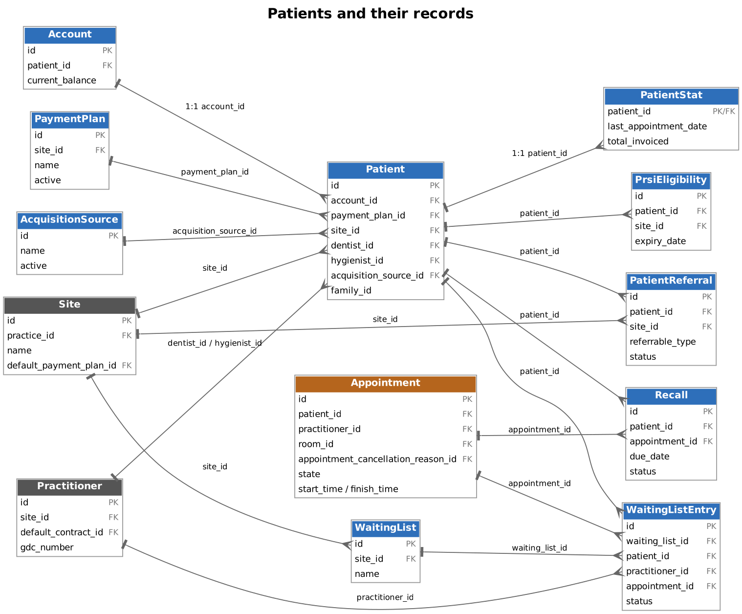

2. Scheduling
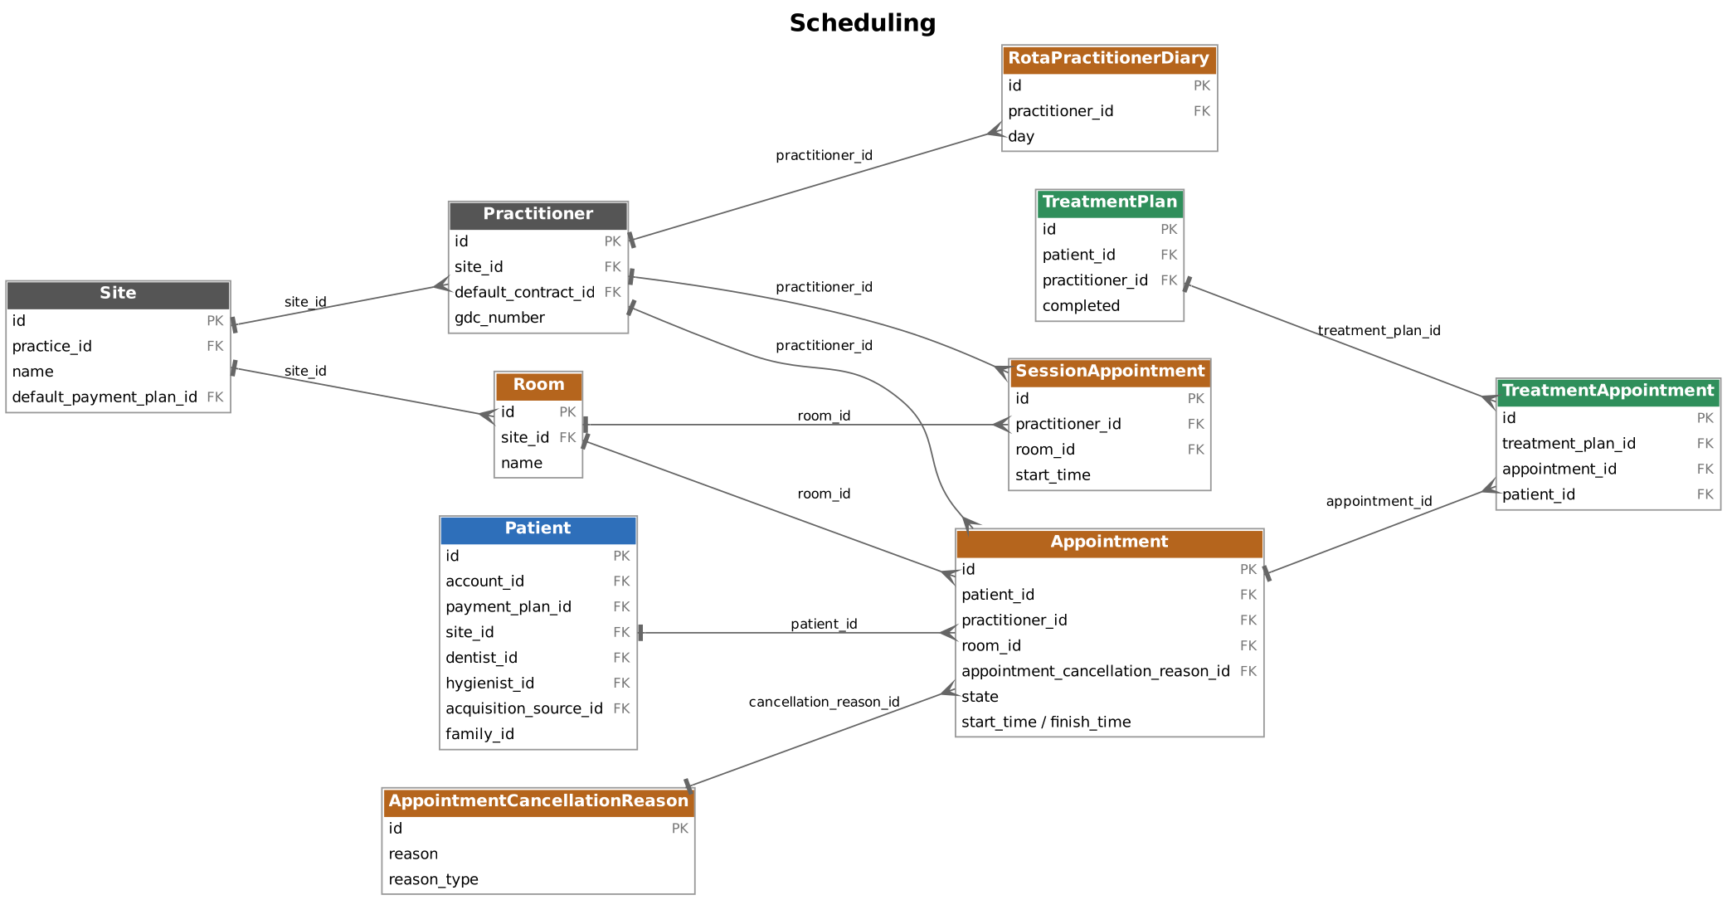

3. Treatment, fees and NHS claims
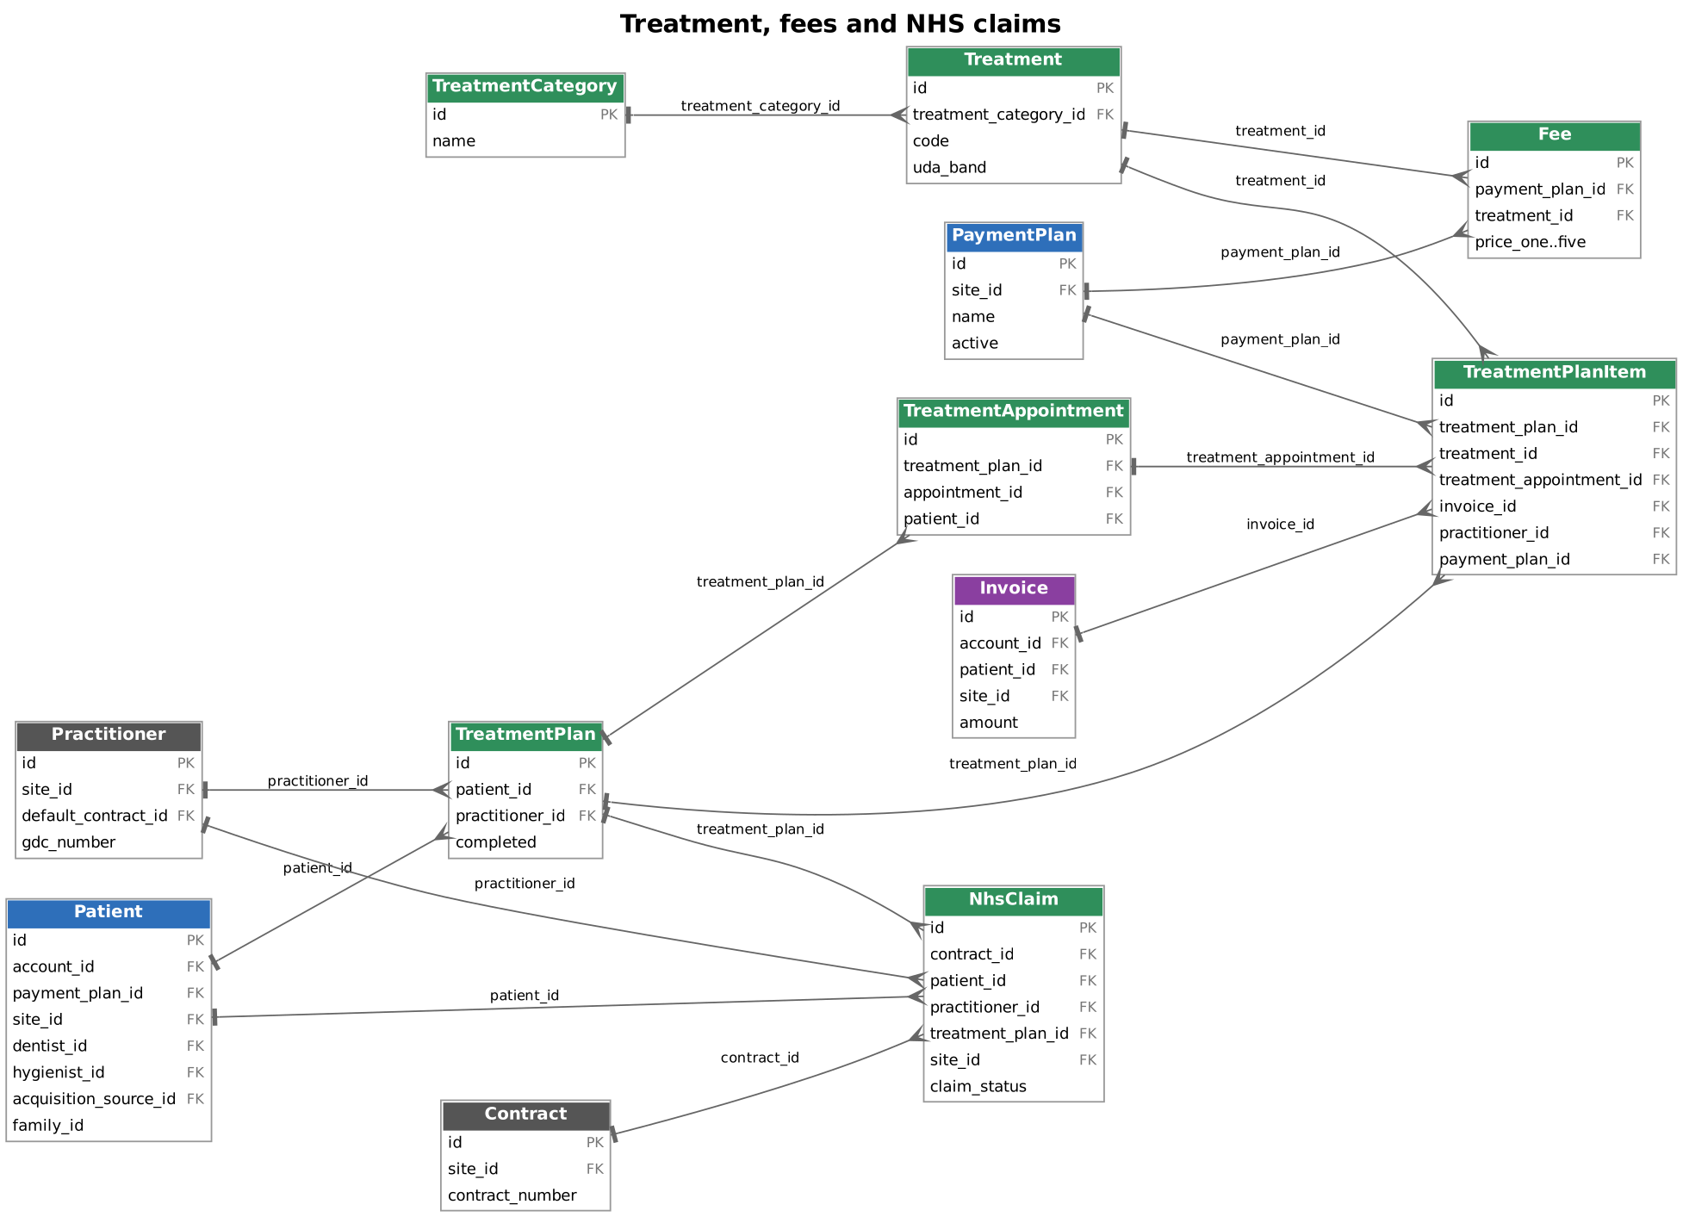

4. Billing and payments
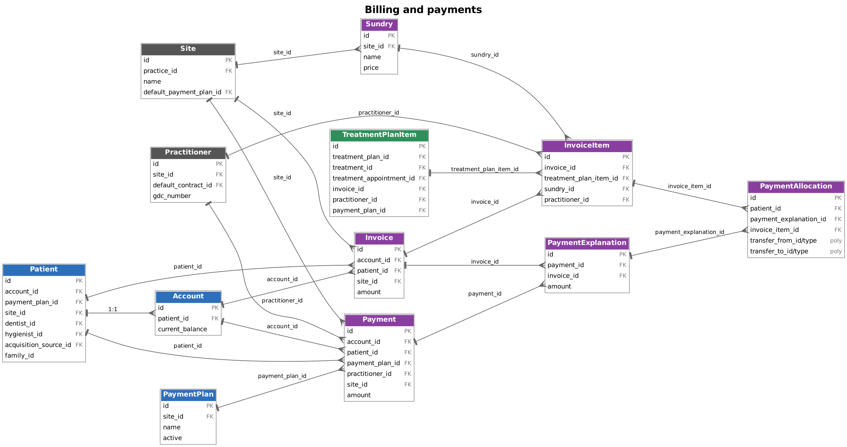

5. Practice structure
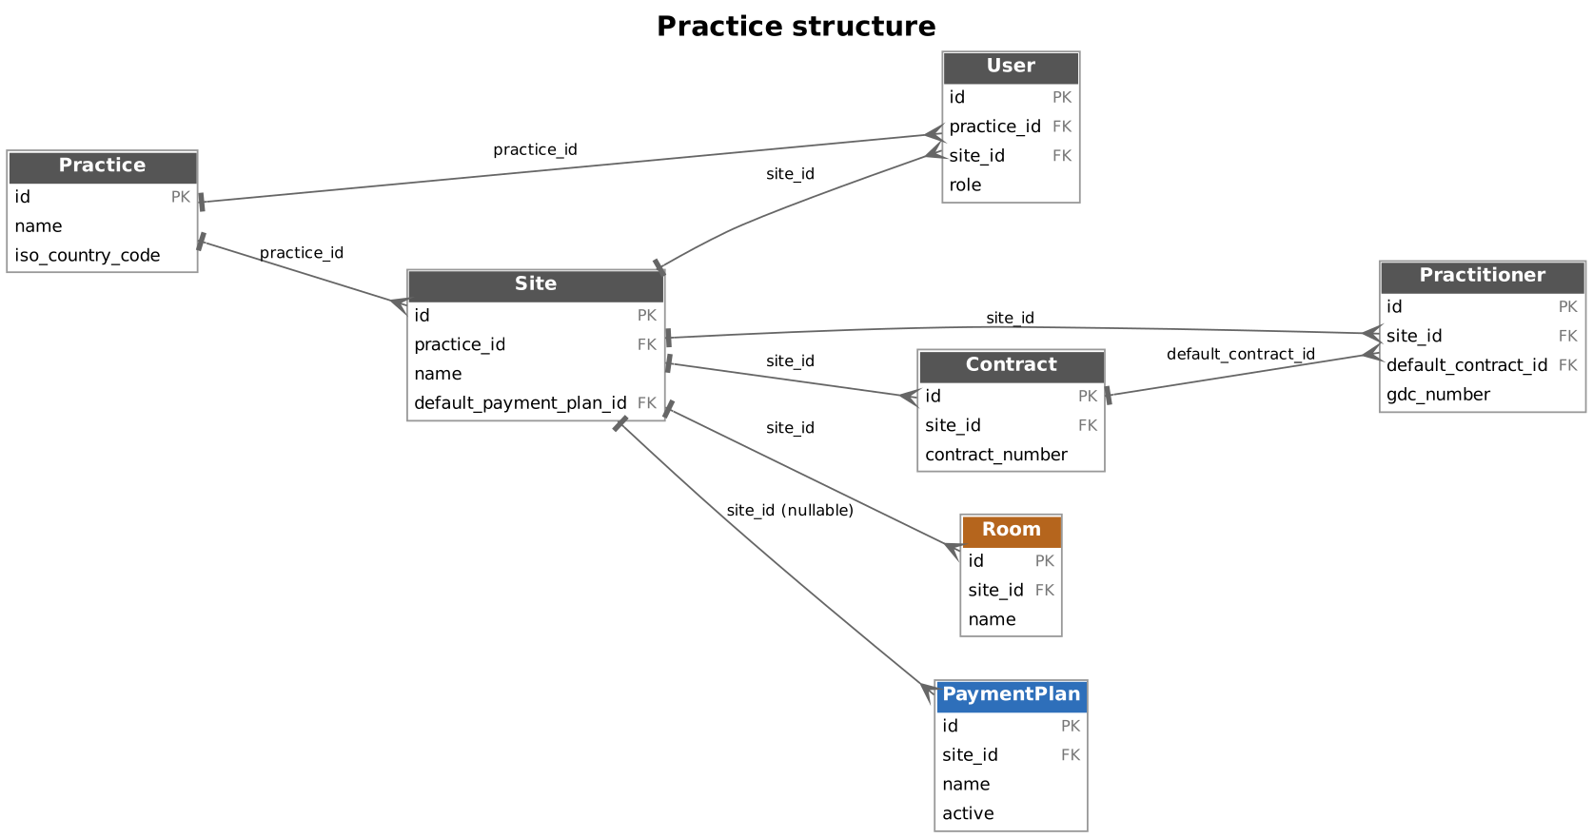
Notes on the diagrams
- Payment allocations use polymorphic transfer_from and transfer_to (id plus type), so they have no single FK target.
- custom_fields are polymorphic and attach to several resources, so they are not drawn.
- Appointments reference cancellation reasons by id, but appointment reasons are matched by name rather than id.
- Webhooks are standalone and have no FK relationships to the other entities.
- Only the key fields of each entity are shown. The endpoint samples above list the full field sets.

Gaps in the source docs
The samples are built from the published examples and attribute tables, not from live calls. The source has several inconsistencies, so test the shapes below against the sandbox before relying on them.
Where | What the docs show | What this document does
Get a contract | Response is wrapped in nhs_claim | Wrapped in contract
Get a waiting list | An array of one under waiting_list | A single object
Sundries (get and list) | Both return an array under the key sundry | Reproduced as documented
Waiting list entries | Path shows /{WAITING_LIST_ID}, example uses ?waiting_list_id= | Query parameter
Payment explanation (get) | Singular path /v1/payment_explanation/{id}, while create and delete use /v1/payments/{id}/explanations | Reproduced as documented
Payment allocations list | Example URL has a typo, payment_allocationss | payment_allocations
Webhooks list | Each item is wrapped in its own webhook key | Reproduced as documented
NHS claim | Example claim_status is complete but the listed values say completed. created_at is malformed | completed and a valid timestamp
Create a payment plan | Example response is NHS, active: false, id 1 for a request that creates "Custom Plan" | Response matches the request and the documented defaults
Appointments | uuid and booked_via_api are in the attribute table but missing from most examples | Included
Invoices and items | Tables type amounts as integer and ids as uuid, but examples use strings and numeric ids. status appears in examples only | Followed the examples
Patients | marketing and medical_alert are typed integer in the parameter tables but are booleans in responses | Booleans
Appointment availability | Example dates are in 2015, but start and finish must be in the future | Dates moved to October 2026
Treatment category | The object example has no wrapper, but get and list do | Wrapped
Also worth knowing: the /rate_limit endpoint has no /v1 prefix, and the Practitioner list takes either site_id or site_id[].

